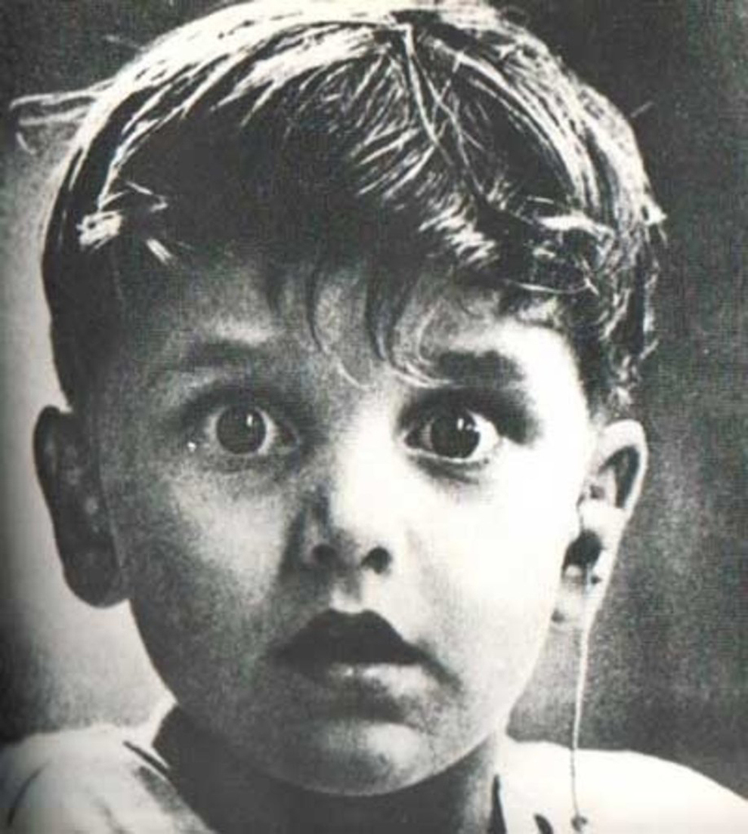
Sample:Reader response to text.
This image captures a very interesting expression on a young boy’s face. He appears to about three or four years old and he looks surprised. His eyes are wide open, his mouth is slightly ajar and it is as if the photographer caught him at a perfect moment. The two most interesting aspects of the image are the grainy black and white quality as well as the earpiece (looks like an ear bud) hanging from his ear. In 2016, I would assume this was an ear bud for music, but the image looks old so it could be something else. What is clear, though, in the photo is the boy is hearing something that has caused a distinct reaction, one of surprise.
Through research I found out this image captures the first time this boy heard sound. A doctor has just placed a hearing device in this ear and a whole new world opens up for him. Knowing this, I now realize the image shares for me an important experience in this young life. Perhaps he had never heard his parents’ voices or his own laughter. Thinking about these aspects of the image, makes me think about how fortunate we are to live in a time when so many advances in technology and medicine provide many people with opportunities to have a better quality of life. We now have cochlear implants, for example, and there are creative thinkers out there constantly seeking better ways of helping others.
The young boy’s face is a good symbol of how important it is to keep working towards cures and devices to help all humans experience life to the fullest. (300 words)

