Speaking and Listening Exercise #1: Sharing Powerful Images
Directions: Share your image with five other students in a 2-3 minute presentation. The groups will be decided by your teacher and an ipad will be used to capture the content of the presentation as an audio file. You should Introduce and discuss your chosen image so that it is clear why you chose it, what it makes you think about and why you believe it is a powerful and/or important image. You are also encouraged to briefly teach your group about any of the relevant history that matters to your image.
Assessment Target: You are trying to show you can effectively plan and deliver content to an audience.
The speaking and listening outcomes make up 25% of your course mark and this is your first chance to show you are working on the following:
- Participating in a range of speaking and listening situations
- Demonstrating awareness of active listening and respect for the needs and feelings of others
- Adapting your communication style to suit delivery of content to an audience
- Recognizing that oral communication involves physical qualities and language choices,depending on the situation.
Criteria | Level 1 | Level 2 | Level 3 | Level 4
Preparation and Content Development | Topic/Main idea is not present, or a main idea is not developed. | Topic/Main Idea is evident and somewhat developed through details. Some may be irrelevant. | Topic/Main Idea is developed using clear and relevant details. | Topic/Main points developed using vivid and relevant details.
Communication of Ideas to Audience  ( PVLEGS) | Delivery is random and/or inappropriate. | Delivery falters but basic communication of main points is achieved. | Delivery is engaging and includes techniques which appeal to audience. | Deliver is skillful using a variety of techniques to appeal to audience.
The infographic below is important as it shows you there are two parts to the process- planning and delivery!
Source of Infographic http://www.davestuartjr.com
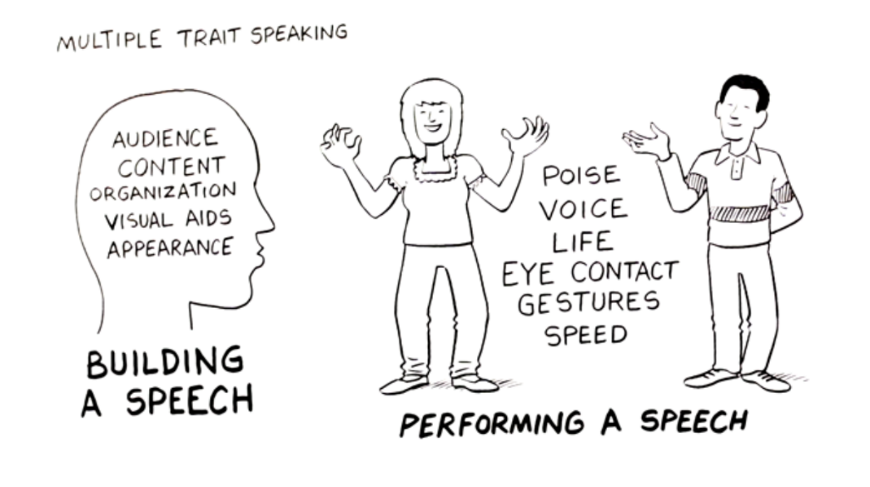Due date: ___________
Checklist:
____1. Have a PRINT COPY of image with you.
____2. PLAN content.
.____3.Rehearse content.
____4. ISOLATE and practice ONE aspect of PVLEGS

